Residual Bequest.  I hereby give, devise, and bequeath to the North Shore Unitarian Church Trust Fund, a non-profit organization located at 2100 Half Day Road, Deerfield, IL 60015, Federal Tax ID #36-3912041, [ALL or a PERCENTAGE] of the rest, residue, and remainder of my estate to be used for the NSUC Trust Fund’s general use and purpose.  Contingent Bequest.  If [primary beneficiary] does not survive me, then I hereby give, devise, and bequeath to the North Shore Unitarian Church Trust Fund, a non-profit organization located at 2100 Half Day Road, Deerfield, IL 60015, Federal Tax ID #36-3912041, [Description of funds or item bequeathed] to be used for the NSUC Trust Fund’s general use and purpose. | BENEFITS OF BEQUESTS  Your bequest:  - Is a revocable gift; it can be changed or modified at any time.  - Can be for a general or specific purpose (unrestricted or restricted).  - Is exempt from federal estate taxes.  - If your estate is taxable, may offset or eliminate estate taxes, resulting in a larger inheritance for your heirs.  HOW CAN I LEARN MORE?  Questions/Suggestions can be directed to:  trustfund@nsuc.org  Or:  NSUC Trust Fund  2100 Half Day Road  Deerfield, IL 60015  Telephone:847-234-2460  Copyright © 2017 by the North Shore Unitarian Church Trust Fund |  | 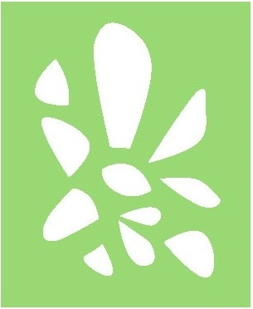  NSUC  TRUST FUND  Leave a Lasting LEGACY…  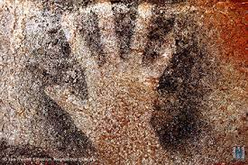  A bequest to the NSUC Trust Fund in your will or living trust is a gift to the future.

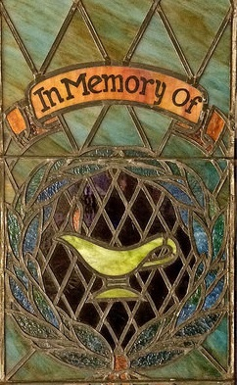  TYPES OF BEQUESTS  Specific Bequest. This bequest involves making a gift for a specific dollar amount. For example, you may wish to leave $10,000 to the NSUC Trust Fund.  Percentage Bequest. You may wish to bequeath a percentage of your estate to the NSUC Trust Fund.  Residual Bequest. This bequest covers the balance of an estate after all other specific bequests in a will are satisfied. A common residual bequest involves giving a percentage of the remaining balance to the NSUC Trust Fund. | Contingent Bequest. This type of bequest applies only if the intended recipients of your will are not alive at the time of your death. In such a case, the funds or resources are bequeathed to the NSUC Trust Fund.  RESTRICTED BEQUESTS  You can designate that your bequest be used only for a specific purpose. Your attorney can craft language to restrict your bequest to meet your charitable objectives.  If you elect to make a restricted bequest, we recommend that your attorney include the following provision should it no longer be possible to use your gift as you originally intended:  If, in the judgment of the trustees of the North Shore Unitarian Church Trust Fund, it shall become impossible for the NSUC Trust Fund to use this bequest to accomplish the specific purposes of this bequest, the Trust Fund may use the income and principal of this gift for such purpose or purposes as the trustees determine is most closely related to the restricted purpose of my bequest. | BEQUEST LANGUAGE  In order to make a bequest, you should speak with your attorney, who can help you include a bequest to the NSUC Trust Fund in your estate plan. Below we have provided some basic language to assist you and your attorney.  Specific Bequest.  I hereby give, devise, and bequeath [insert amount] ($XX,XXX.00) and no/100 dollars to the North Shore Unitarian Church Trust Fund, a non-profit organization located at 2100 Half Day Road, Deerfield, IL 60015, Federal Tax ID #36-3912041, for the Trust Fund’s general use and purpose.  Percentage Bequest.  I hereby give, devise, and bequeath ___ percent (__%) of my total estate, determined as of the date of my death, to the North Shore Unitarian Church Trust Fund, a non-profit organization located at 2100 Half Day Road, Deerfield, IL 60015, Federal Tax ID #36-3912041, for the Trust Fund’s general use and purpose.

